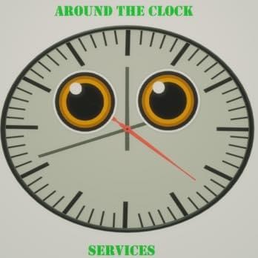

The Importance and Convenience of Remote Online Notarization for the Elderly and Sick

By Mickey B.
Remote Online Notarization (RON) has transformed document notarization by providing a safer, more convenient, and secure alternative for individuals who have difficulty traveling to a traditional notary office. This is especially valuable for elderly individuals in nursing homes, assisted living facilities, rehabilitation centers, and hospitals, as well as those with illnesses or mobility limitations.
For many seniors and patients, leaving their residence or hospital room can be physically challenging, costly, or medically impossible. RON removes these barriers by allowing individuals to connect with a commissioned notary through a secure online platform from the comfort of their home, room, or care facility. Family members, caregivers, and medical staff no longer need to arrange transportation or coordinate in-person visits solely for notarization.
A key advantage of RON is its ability to reduce witness-related challenges. Finding qualified witnesses can be difficult, particularly for elderly individuals with limited visitors or nearby family. Depending on state law and document requirements, remote notarization platforms may allow approved witnesses to participate online, streamlining the process and reducing delays in completing important legal, financial, and healthcare documents.
RON also offers fraud prevention measures that often exceed those of traditional paper notarizations. Modern platforms use identity verification, credential analysis, knowledge-based authentication, and secure digital audit trails to help confirm signer identity and ensure the process is conducted lawfully and securely.
Another valuable feature is the audio-video recording of the notarization session. The interaction between the signer and notary is recorded and securely stored in accordance with state regulations, creating a permanent record of identity verification, willingness to sign, and competency during the process.
These recordings provide important protection for all parties. If a document is challenged, the recording can demonstrate that the signer acted voluntarily, understood the document, and completed the notarization properly. This added transparency helps reduce the risk of fraud, coercion, forgery, and disputes over validity.
For nursing homes, hospitals, assisted living facilities, attorneys, healthcare providers, and families, RON offers a practical solution that combines accessibility, convenience, security, and accountability. It enables elderly and sick individuals to complete important legal and financial transactions without unnecessary travel while benefiting from advanced safeguards and documented notarization sessions.
As technology expands access to essential services, Remote Online Notarization remains a valuable tool for protecting vulnerable populations and ensuring important documents can be executed safely, efficiently, and confidently.

